**PHASE 1 – RELEASE DOCUMENT**

**STEP -1**

Login to the Hippo application using valid credentials

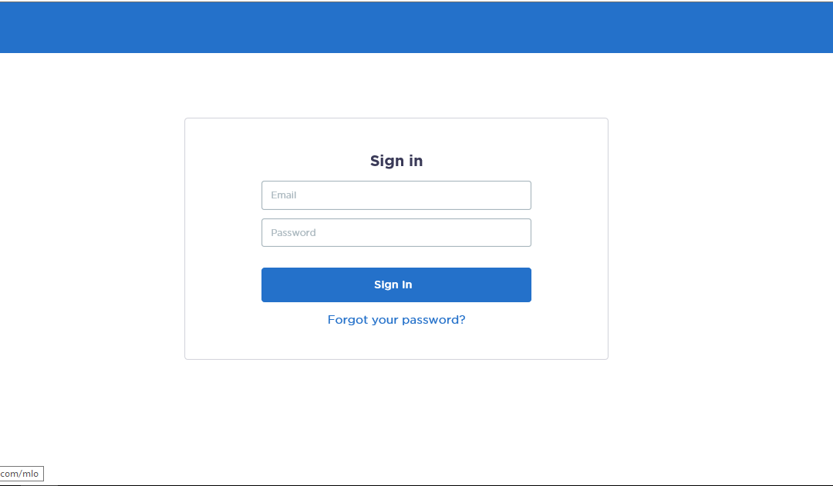

**STEP -2**

Loan applicants are filtered based on “New Lead” and Go Live Date filters. Applicant’s details are scraped from all the filtered pages and saved for further processing.

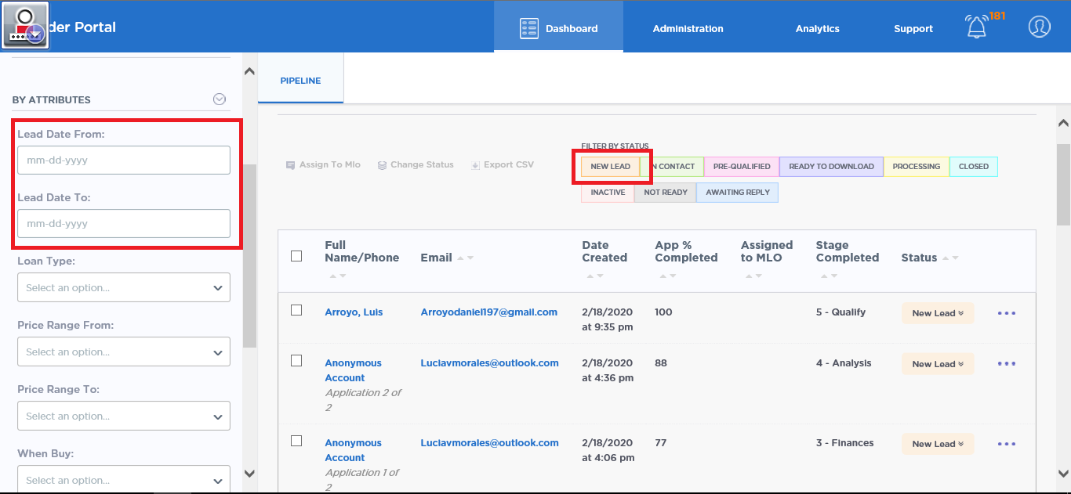

**STEP -3**

For each applicant, 1003 form is opened and checked for the presence of SSN. If SSN is not found, that applicant is skipped and the process continues for the next applicant.

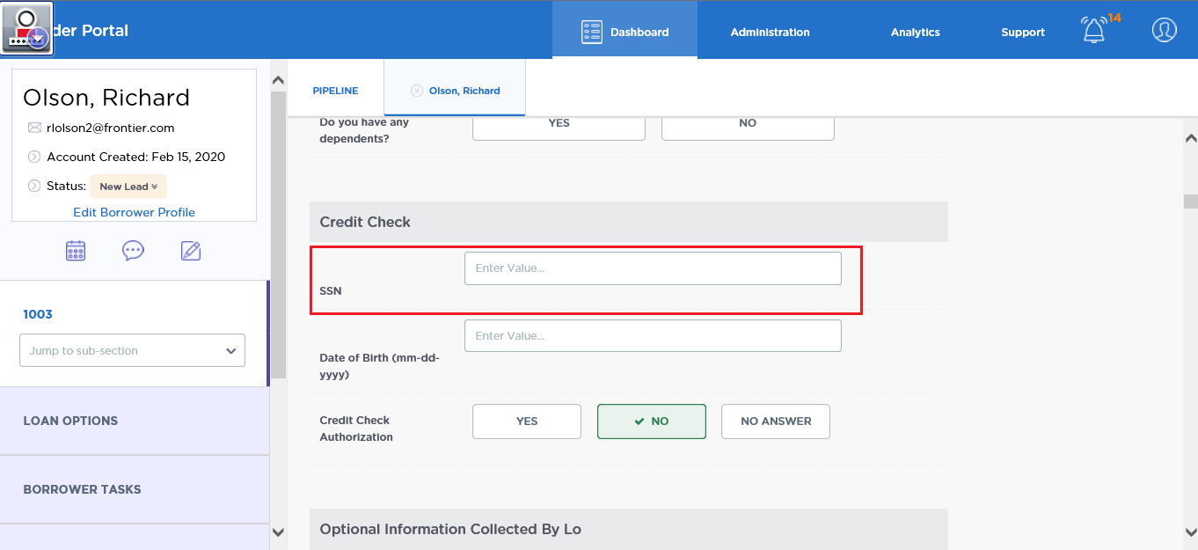

**STEP-4**

If SSN is found, the FNM file is downloaded. Documents tab is opened and the files available under the “Lender Only Documents” and “Borrower Accessible Documents” are downloaded and saved in the folder created for that applicant.

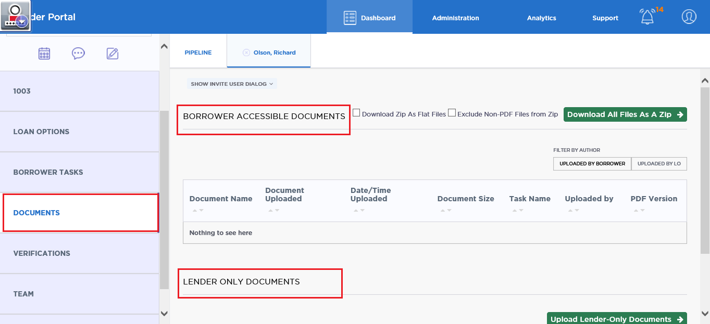

If an applicant contains a zipped folder of documents, then a template folder is created imitating the virtual loan folders. Each of these documents is added to appropriate folders based on the matching of keywords.

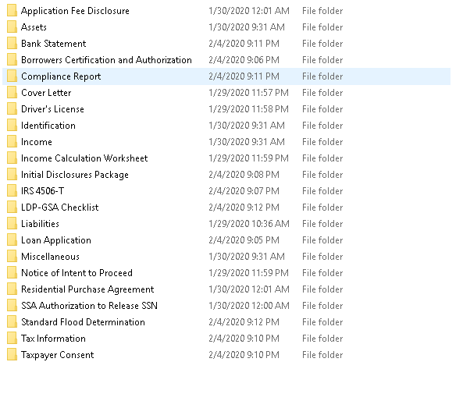

**STEP-5**

Once the steps mentioned above are completed for all the filtered applicants, the bot logs out from the Hippo application and logs into the Cadence application

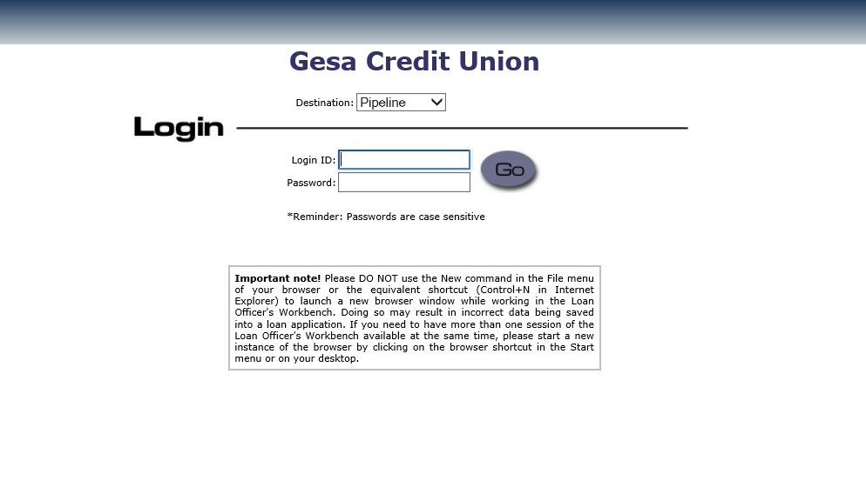

**STEP-6**

Once logged in successfully, the bot navigates to import application page and uploads the FNM files previously downloaded from Hippo.

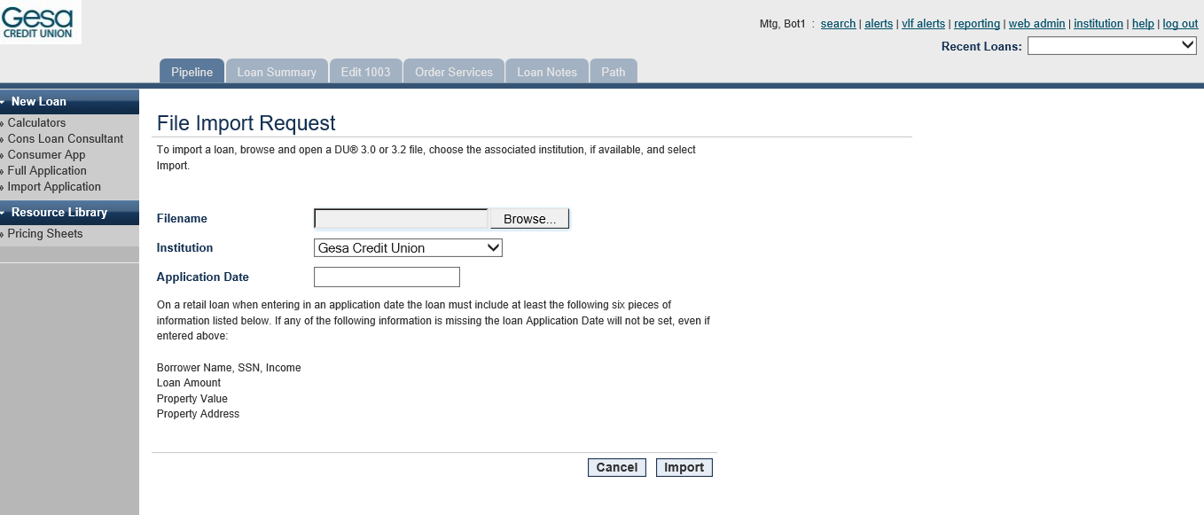

**STEP-7**

After the FNM file has been uploaded, Borrowers page under edit 1003 is opened and the ssn is extracted and saved for further processing.

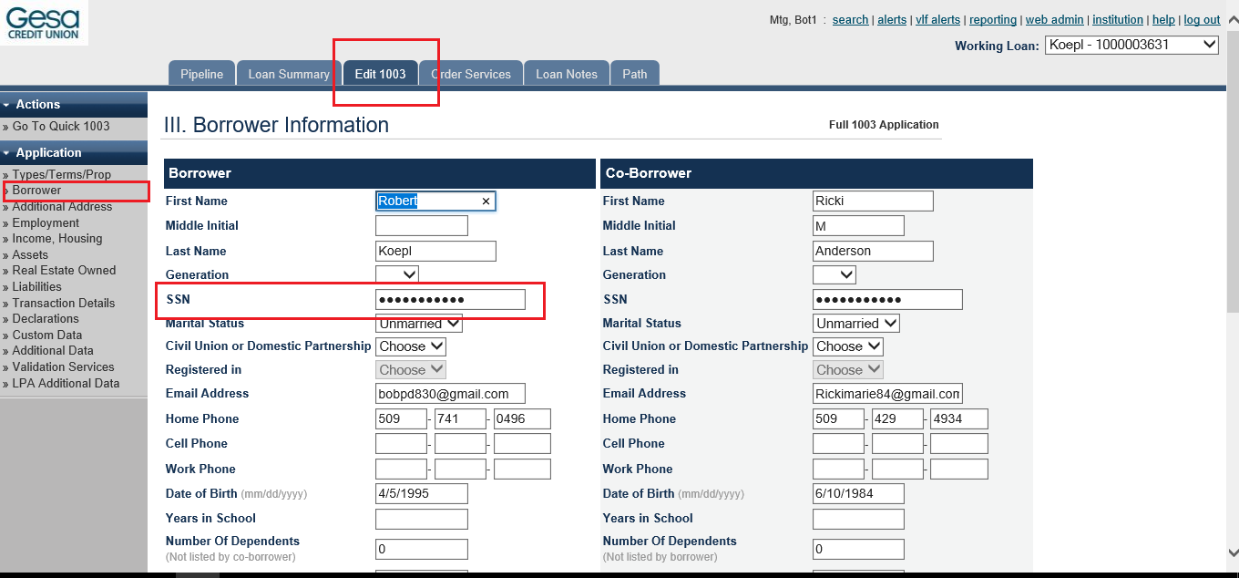

**STEP-8**

If a credit report had been downloaded from Hippo, the bot navigates to order services tab and reissues the credit report.

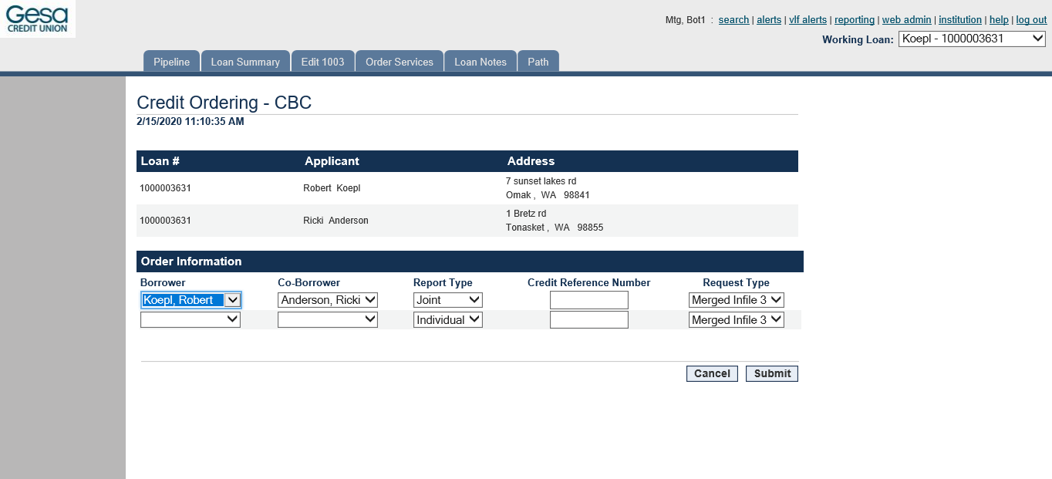

**STEP-9**

If no credit report had been downloaded, the bot navigates to the edit 1003 tab and updates the county and property address appropriately.

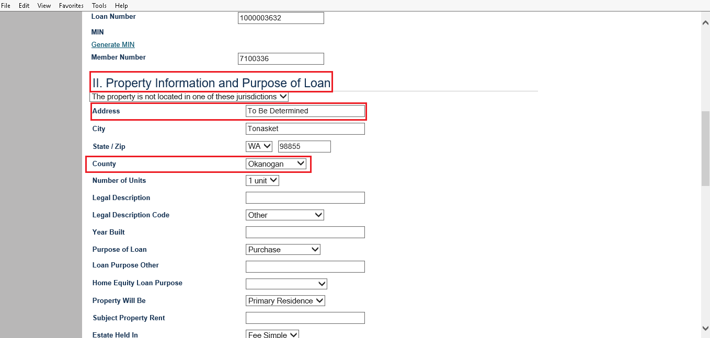

**STEP-10**

The bot now opens the liabilities page and deletes the existing liabilities and populates new liabilities.

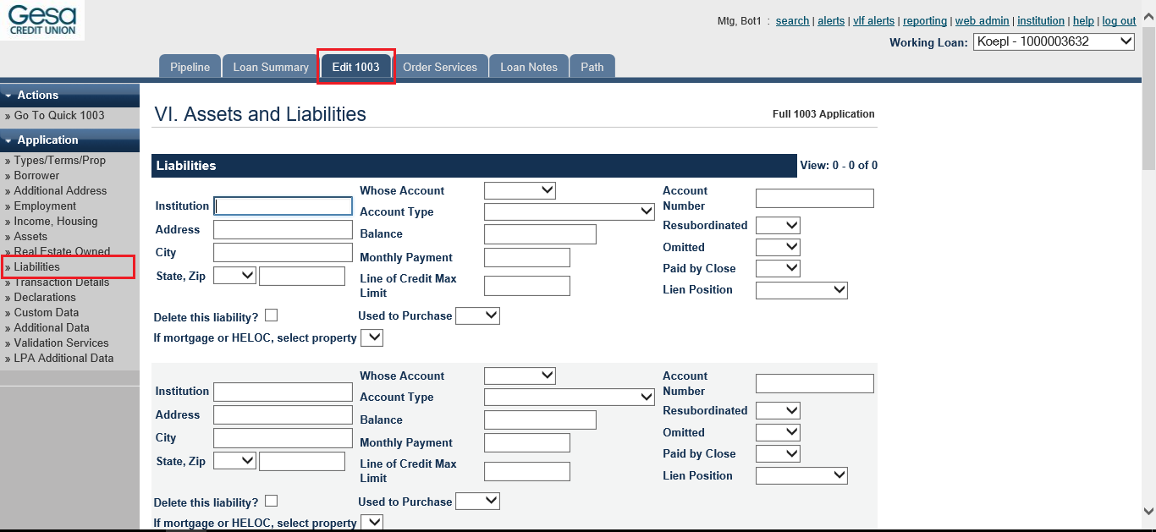

**STEP-11**

It now navigates to the declarations page of edit 1003 and assigns a MLO officer to the applicant based on the county.

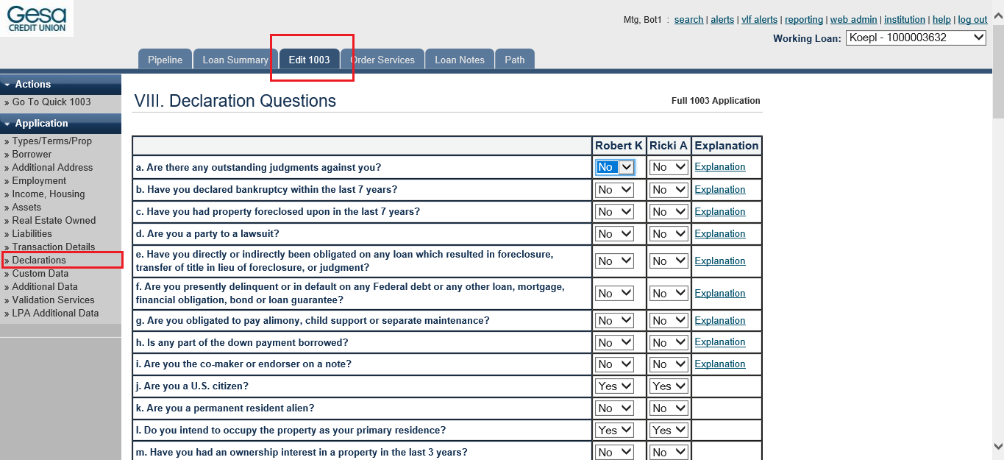

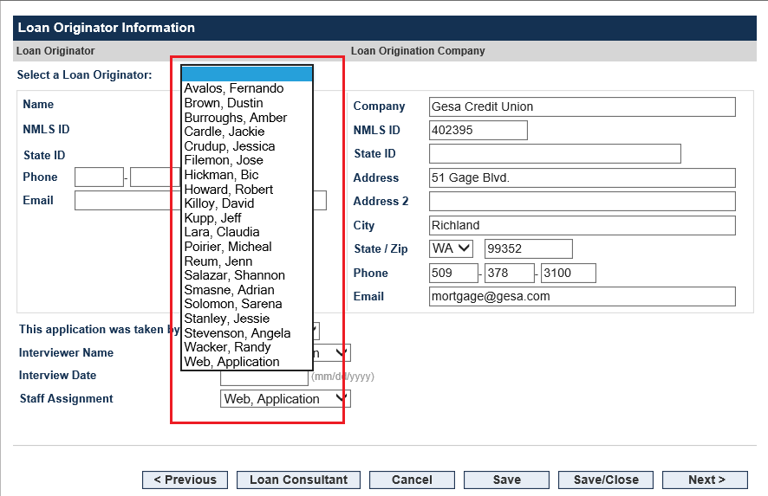

**STEP-12**

DNA application is opened and the SSN that was previously extracted is searched. If no search results are found, appropriate comments are added in the comments section of path tab and saved.

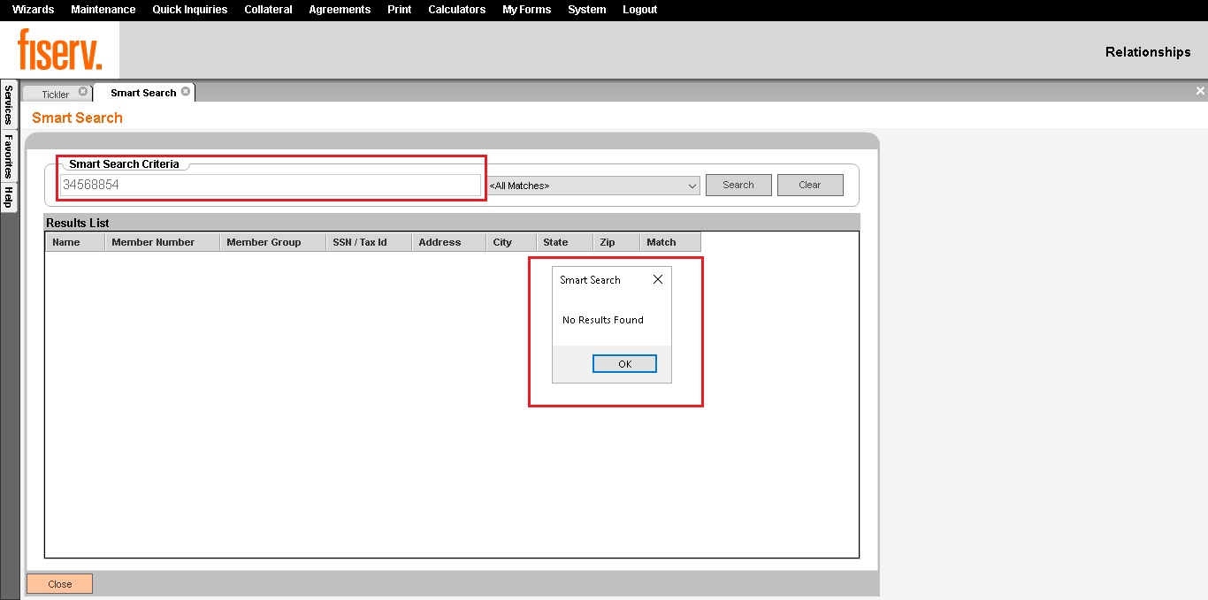

**STEP-13**

If there are any search results found, the bot checks if the primary borrower has an active account. If yes then it extracts the member number from DNA and updates the same in the review application page under path. Else it will updated the comments sections under path and save the record

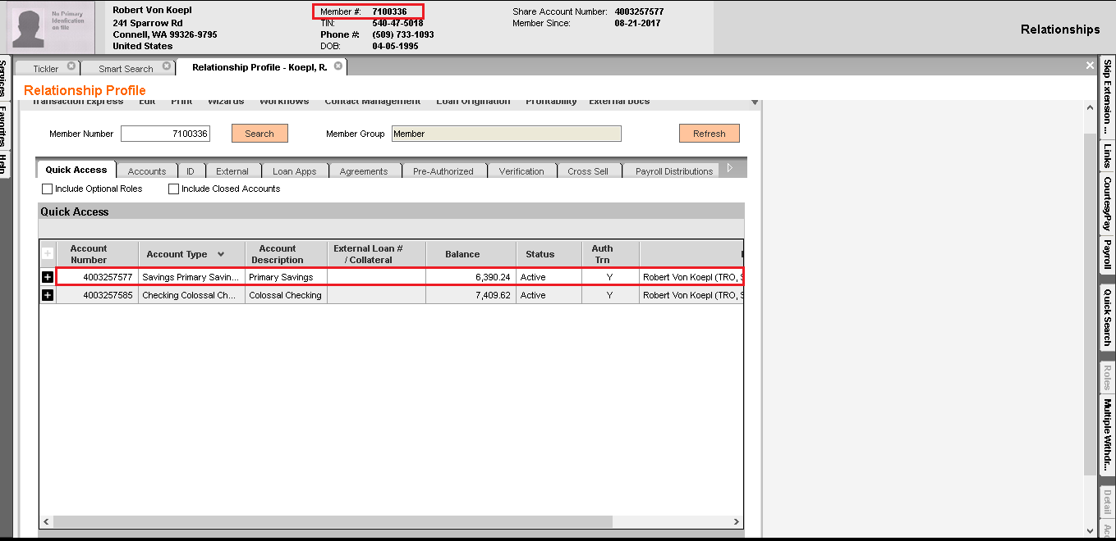

**STEP-14**

The bot now navigates to the consumer login page under loan summary. It generates a username and password for the customer to login to their account.

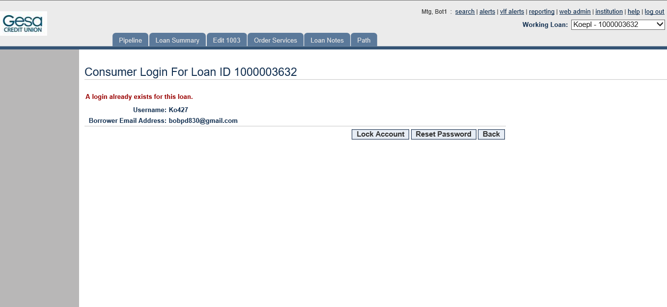

**STEPS-15**

Next, the bot opens the email borrower page under loan summary and scrapes the email addresses provided by the customer. It then sends an email to them in the name of the assigned MLO officer along with their login link and credentials.

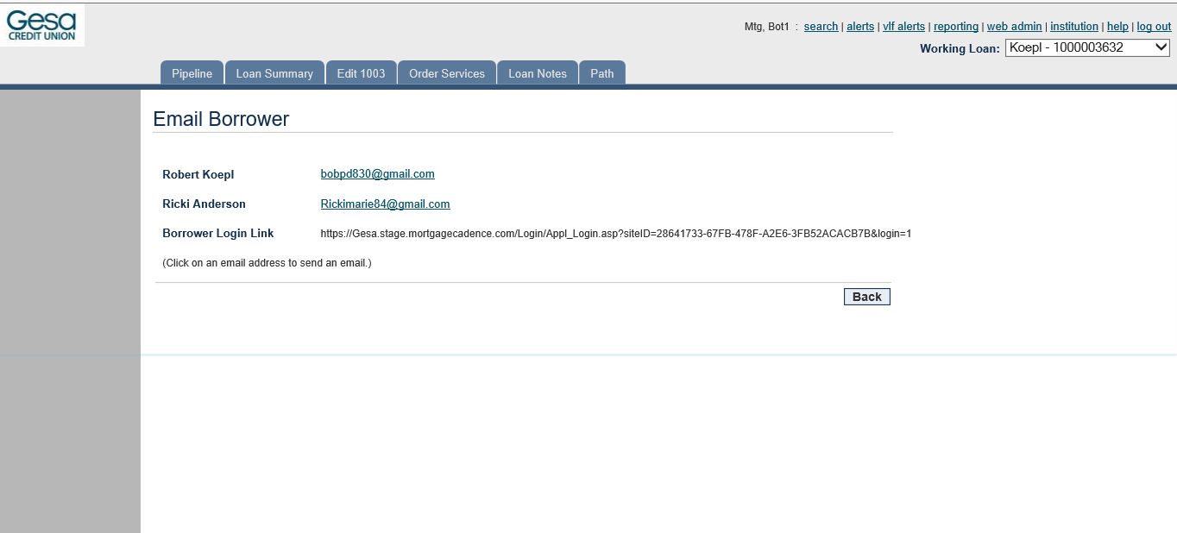

**STEP-16**

Now the bot opens the virtual loan folder from the loan summary page and uploads all the files present in the template folder and saves them under right folder names.

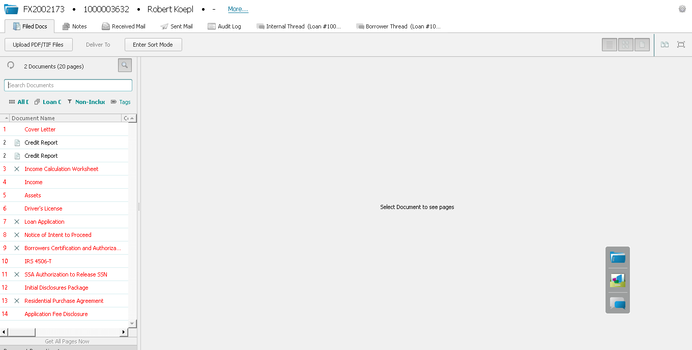

**STEP-17**

This marks the end of cadence application for one applicant. The bot continues to do the above processes for the rest of the applicant and logs out once all the applicants have been processed.

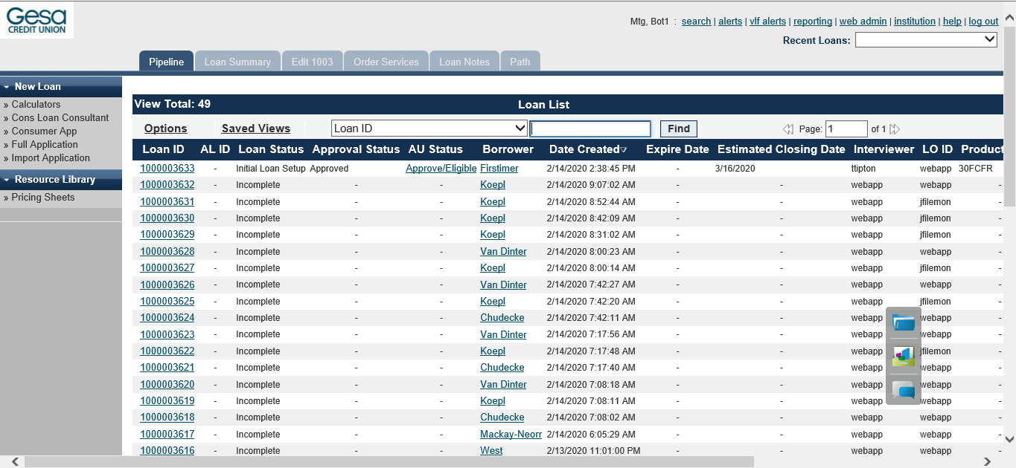

**STEP-18**

The bot once again logs into the Hippo application and changes the status of all the cadence processing completed files from “New Lead” to “Processing”. 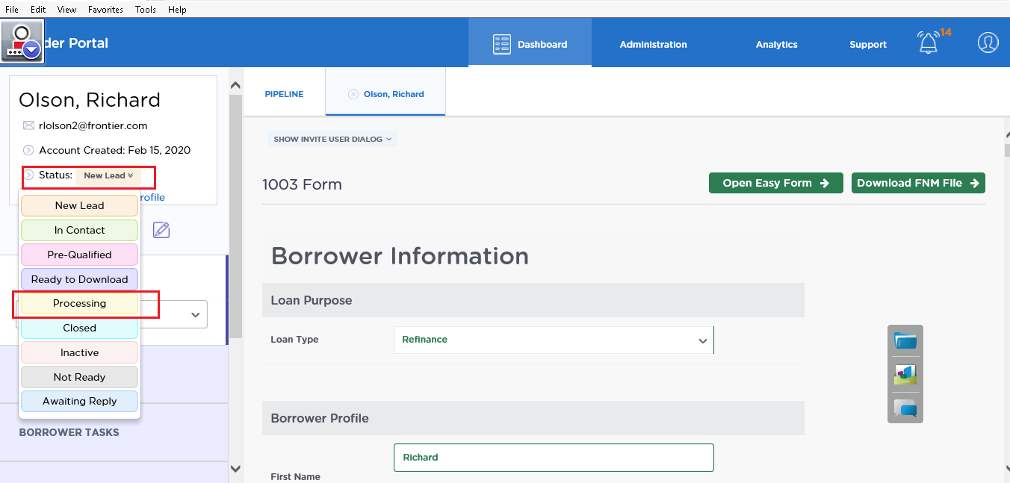

**STEP-19**

Finally, assignment of MLO takes place to all the applications marked as “Processing”. Once the MLO’s have been assigned, the bot logs out of the hippo application.

